JAN TERLOUW: “GIVE THE FUTURE A CHAIR”
The interview between three ‘Future Leaders’ of the Dutch Green Building Council and Jan Terlouw on August the 16th became the start of a special mission. A mission inspired by a passage from Terlouw his book ‘Het Hebzuchtgas’.
Lizzy Butink (a.s.r. Real Estate Investment Management), Marianne Davidson (VolkerWessels Vastgoed), Pamela Logjes (Dutch Green Building Council), Yvette Watson (PHI Factory) and Jan Terlouw, all passionate for a sustainable world, challenge everyone to literally give the future a chair. The goal is to bring the need for a sustainable future to our attention daily.
#Futurechair
From now on the initiators will scoot in an empty chair in all their meetings and events. "It is important that we value the future in every decision we make." The meaning of the chair can be different for everyone. It can offer a new perspective, a place of thought, or maybe you'll see your own child or grandchild there. This is how we give the future a voice. Imagine an empty chair in every boardroom, classroom, talk show and even in the parliament. An empty chair intended for the future.
Future perspective
Sustainability is about a beautiful world for future generations. Perhaps you do not give sustainability a lot of thought in your daily activities, but everybody cares for their future. As Jan Terlouw has stated in his plea in the tv show ‘De Wereld Draait Door’, it is about trust and the importance of a viable earth for future generations. That is why we must take the future into account in our choices today. Give the future a chair!
Will you give the future a chair? Share your stories and photos through #toekomststoel and visit www.toekomstestoel.nl for more information.
The entire interview with Jan Terlouw, Yvette Watson, Lizzy Butink and Marianne Davidson will be published shortly in the Dutch Green Building Week magazine (www.dgbw.nl).
More information about this initiative?
initiatief@toekomststoel.nl & +316 24 64 33 04

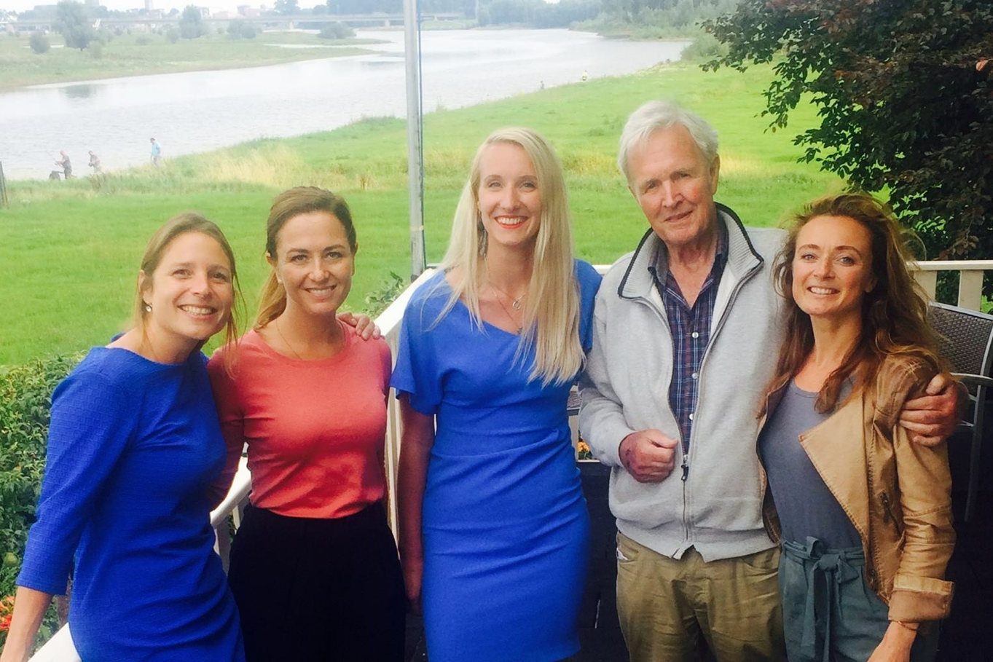
Left to right: Yvette Watson (PHI Factory), Marianne Davidson (VolkerWessels Vastgoed), Lizzy Butink (a.s.r. Real Estate Investment Management), Jan Terlouw, Pamela Logjes (Dutch Green Building Council)

